Meeting 12-04-2021

**Summery by:**

Daniel Tøttrup

**Time and place:**

date – Zoom

**Participants:**

Daniel Tøttrup

Stinus Lykke Skovgaard

Jonas Le Fevre

Rui Pimentel de Figueiredo

**Agenda:**

* Weekly meeting

**Summery:**

* Look into how to test the model.
  + Fx. Extract ground truth values from the simulation data (like truth vale of time to collision)
  + Evaluate each part of the system accordingly to how that part should be tested (how mask rcnn is evaluated in the literature, how object tracing is evaluated in the literature (MOT challenge))
  + 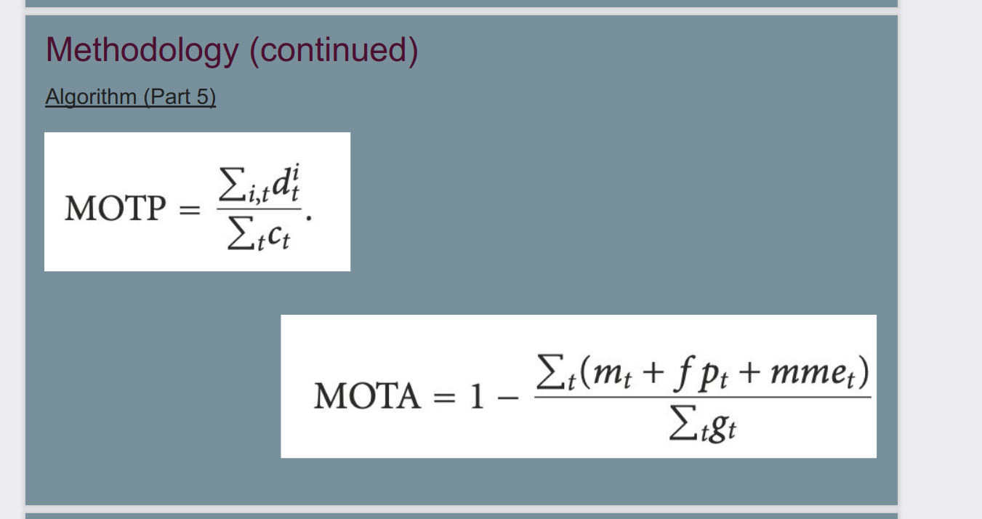
  + Compare semantic segmentation approaches
  + Evaluation is very important!
* Calculate time to collision
* When we write our thesis, we should write our main goal is to calculate the time to collision between ships or smaller boats
* Write every day
* Main contribution and